Learning Trajectory for Learning Multiplication Rules with Islamic Values using Realistic Mathematics Education Approach
dsdna
Yoga Dwi Windy Kusuma Ningtyas^{1*}, Chusnul Khotimah Galatea², Naufal Ishartono³, Lilis Oktavia⁴
^{1, 2, 4} Pendidikan Matematika, FKIP, Universitas Muhammadiyah Jember
³ Pendidikan Matematika, FKIP, Universitas Muhammadiyah Surakarta

*Email Korespondensi: kusumaningtyas.dwi@unmuhjember.ac.id
Info Artikel (11 pt) |  | Abstract (11 pt)
 |  | This paper aims to investigate how a learning trajectory (LT) of multiplication rules support students in developing their understanding and reasoning skills. The learning activities in LT are developed by using Realistic Mathematics Education approach with Islamic values embedded. This study employed design research, which involved a cyclical process of preliminary design, experimental design, and retrospective analysis. The data were collected from 30 tenth-grade students an Islamic senior high school in Jember, Indonesia. The data collected from literature reviews, observations, interviews, videotaping, and tests. The results depicted that the LT of multiplication rules based realistic-Islamic context can support students’ thinking and reasoning about the concepts of multiplication rules. Most notably, the Islamic content and context may teach good deeds and principles that may be applied to students’ daily life.
  Diterima | :
  Direvisi | :
  Diterbitkan | :
Keywords:
RME, LT, multiplication rules, design research
Cara merujuk artikel ini:
Nama belakang, singkatan nama depan, dst. (Tahun). Judul artkel dalam bahasa Indonesia. Vygotsky: Jurnal Pendidikan Matematika dan Matematika, volume (nomor), halaman. Diunduh dari https://www.xxx.
Copyright © 2021 Vygotsky: Jurnal Pendidikan Matematika dan Matematika. All right reserved

INTRODUCTION
Learning permutations and combinations is similar to practicing counting principles, which are highly important for daily tasks. Humans are able to mention the number of possible occurrences or ways that an event might occur by employing the idea of this counting rule. It is essential for all teachers, in Islamic schools especially, to begin incorporating Islamic ideals into the instructional plans they design, down to the enumeration procedures. Through education, there are many fantastic chances for pupils' character development. It may be used by educators through promoting instructional strategies built on moral character (Abdussakir, 2017). Education that incorporates values, shari'a, and religious belief is known as such by researchers. The educational process in schools is then interwoven with these principles (Nihayati, Suningsih & Abdullah, 2018).
Education reform is urgently required due to the moral degradation and absence of religious principles (Maryati, Iyam; Priatna, 2017; Rahman et al., 2015). However, this wish has not come true. With the exception of Islamic beliefs, mathematics is often taught as a single topic. Due to its rigidity, complexity, and alienation from real-world situations, mathematics study eventually turns into a topic that pupils tend to avoid. The development of Islamic values and character is less possible with mathematics. The learning achievement in mathematics is often modest, though (Salafudin, 2015).
According to Johnson (2002) and Hadi (2017) pupils will comprehend and retain what they have learnt when they discover the purpose of studying mathematics in school. Students may relate what they learn in class to actual situations they encounter every day thanks to contextual learning. Their context is expanded by contextual information. This is due to the fact that giving pupils fresh experiences might inspire their minds to form fresh connections. Students are able to discover and create meaning on their own as a consequence.
The development of pupils' thinking abilities requires the use of appropriate learning tactics and approaches. It is founded on a focus on reforming technical and mathematical skill education (Irawan & Kencanawaty, 2017; Sembiring et al., 2008). The reform is built on fostering problem-solving abilities in daily life. Realistic Mathematics Education (RME) learning, which underpins the learning processes of daily life, can help with this (Zulkardi et al., 2020). Students engage in an activity in the form of rediscovering concepts through activities that students conduct themselves (van Galen et al., 2008; Zulkardi et al., 2020). RME places a lot of emphasis on real-world situations, which implies that students are given challenges that they can see (Van den Heuvel-Panhuizen & Drijvers, 2020). The ability to use pedagogical strategies will be needed for problems that students can visualize and solve. RME is therefore one of the factors taken into account as a learning technique so that students may comprehend each activity in relation to the requirements and experiences of students connected to statistics with everyday life.
The five principles of realistic mathematics education outlined by Treffers (2012) served as inspiration for the process of designing a series of learning activities in this study, beginning with experience-based activities. These five principles are: using context, models for progressive mathematization, utilization of students’ own construction, interactivity, and intertwinment.
According to Kuntowijoyo (2001) religion and culture are two factors that interact and affect one another to create symbols, content, and values. It was previously explained that certain mathematical symbols had meanings based on religion and society. This means that it can also be used in RME with the principle of real context, not meaning concrete, physical, and tangible, but also covering what that the student's mind can imagine, especially when the context of speech enters the realm of religion (Abdussakir, 2017), an Islamic value-based context that students frequently do in everyday life.
Mathematics education that incorporates Islamic subtleties is education that, during the learning process, is based on Islamic principles (Isandespha, 2015). Salafudin (2015) claims that studying mathematics with Islamic values involves include Islamic ideals in each lesson's content and practice problems. Therefore, studying mathematics that incorporates Islamic values is learning mathematics that replaces Islamic values in it. The following values are incorporated into math education, according to Salafudin: (1) aqidah values, or values pertaining to things that the heart must think are true; (2) Shari'ah values associated with a way of life as a guide in living life in the world to lead to the afterlife; and (3) moral values, i.e. values associated with the condition of a person's soul that motivates him to act without first thinking and considering his options, such as morals towards According to the above description, academics are interested in doing research that tries to develop students' learning pathways about the idea of multiplication rules using RME approach with Islamic values.
In this study, utilizing a realistic mathematics education (RME) method and taking into account the challenges experienced by the students as well as the findings of the researchers stated above, we devised a learning trajectory (LT) for teaching multiplication rules. A LT is a set of activities or tasks that students follow to reach a certain learning objective (Elizondo-Ramírez & Hernández-Solís, 2017). A LT is initially created as a hypothetical learning trajectory (HLT) (Gravemeijer, Koeno; Cobb, 2013). To observe the application of learning using the RME technique, researchers created learning in the form of HLT. There are learning phases in HLT that teachers must complete in order to carry out learning. Researchers can speculate about the possible student responses using HLT. The hypothetical learning trajectory (HLT), according to Bakker & Van Eerde (2013), is the link between instructional theory and practical teaching and learning. Three elements make up the concrete form of HLT: learning objectives for students, a sequence of learning activities to promote student learning, and supposed student learning, in which the instructor foresees the growth and thought processes of the class.
A HLT eventually develops into a theory (LT) that other math educators may use as a lesson learnt to teach a specific mathematical topic. This occurs after a cycle of developing, testing, and redesigning. While Cobb et al. (2003) referred to the theory as a domain specific theory, Gravemeijer, Koeno; Cobb (2013) and Liljekvist et al., (2016) referred to it as a local instructional theory (LIT). A local instruction theory is made up of notions about how to learn a particular subject as well as how to facilitate that learning (Clements & Sarama, 2014). In mathematics, scholars created a lot of LTs. They were used to teach some courses in higher education as well as mathematics in primary and secondary schools (see (Afriansyah & Arwadi, 2021; Hendriana et al., 2019; Risdiyanti et al., 2019)). Overall, the research findings showed that LTs were highly beneficial in developing students' conceptual comprehension.
The LT developed for this study were based on key principles of RME concepts for instructional design and as a framework for how the LT was implemented in the classrooms. Based on the arguments above, this study aims to investigate in what extent the learning trajectory of multiplication rules based realistic with Islamic values can support students' thinking and understanding of multiplication rules.

METHOD
This study used design research approach which consists of five characteristics, namely interventionist, process-oriented, reflective components, cyclic characters, and theory-oriented (Nieveen, Nienke; McKenney, Susan; van den Akker, 2006; Prahmana, 2017). In order to improve teaching, the approach seeks to better understand how teaching and learning are interconnected (Gravemeijer, Koeno; Cobb, 2013). This study had three stages: the preliminary design, the experimental design, and the retrospective analysis. The research activities consisted of research phased and its instruments were presented in Table 1.

Table 1. The research activities
No. | Research phase | The activities | Data collection | Instruments
1. | Preliminary design | - Reviewing literatures to gain data about students' obstacles in learning multiplication rules  - Designing hypothetical learning trajectory (HLT) which consist of learning procedures and expected students and teacher’s responses | - Literatures review  - interview  - observation | - literatures  - interview guide sheets  - field notes
2. | Experimental design | Two cycles of testing  - Focus group, to investigate the practicality of the HLT  - Classroom try out: to examine the HLT’s effectiveness on the students’ understanding of multiplication rules | - Test  - Observation  - Videotaping | - written test items  - field notes
3. | Retrospective analysis | Revising and improving the HLT to be LT | Document analysis

The preliminary design produced an HLT of multiplication rule. In the experimental design, testing in small group involved six tenth grade students from an Islamic senior high school in Jember, Indonesia. Following the processes of retrospective analysis and re-design, the HLT was tested to 30 tenth-grade students from the same school. The researchers, the teacher, and the observers participated in the retrospective analysis.

RESULTS AND DISCUSSIONS
The purpose of this study is to support students' understanding of the rules of enumeration in data content.
The HLT for teaching multiplication rules using RME approach was created after conducting recent literature reviews to determine the need analysis, examine the curriculum, and students’ characteristics. The learning series consists of four activities with each context, namely exploring a map for going to a mosque, finding the route for Friday prayer, designing students’ own map, and doing good deeds (Ningtyas et al., 2022).

Table 2. The Learning Trajectory of Multiplication Rules
Learning Activities | Learning Objectives | Students’ responses
Activity 1. Exploring a Map for going to Masjid
- Seeking the essage of ayah about enumeration in Muslim life and hadist about going to mosque  - Seeking the virtue of ayah QS Al Jin: 28  - Seeking the virtue of hadist shahih Muslim No. 1009 | Students are able to understand the introduction of enumeration of an event | - Students know the message of the ayah  - Students do not know the virtue of the ayah  - Students mention the virtue of going to the mosque  - Students do not mention the virtue of going to the mosque
- Exploring the map to determine routes for going to mosque |  | - Students draw the possible routes on map  - Students list the possible routes one by one  - Students cannot fing the route
Activity2: Finding the Route for Friday Prayer
- Seeking the virtue of hadist shahih of going and returning from praying in the mosque with different paths | Students are able to determine the possible routes of two consecutive events. | - Students mention the rewards (pahala) going and returning from praying in the mosque with different paths  - Students do not mention the reward (pahala) going and returning from praying in the mosque with different paths
- Finding the possible routes by exploring the map to determine routes for Friday prayer |  | - Students draw the possible routes on map with two consecutive events  - Students list the possible routes of two consecutive events one by one  - Students cannot find the routes
Activity 3: Designing Your Own Map
- Students find the solution in more formal way. They draw a diagram and the roads are represented as connecting line | Students are able to determine the possible routes and expressing them more formally through the use of diagram and multiplication rules. | - Students can mention a practice for being a good muslim by helping each other  - Students can draw a diagram by connecting each point (houses and mosque) with lines (roads)  - Students draw a diagram with random lines
- Students grasp the conclusion: To find the number of ways of doing something, multiply the number of choices available at each stage (multiple rule) |  | - Students put numbers on the lines they draw and grasp the conclusion of multiplying each number to find the travel routes  - Students put numbers on the lines they draw but they cannot explain any conclusion about multiplying each number to find the travel routes
Activity 4: Doing good deeds
Students find the number of ways of doing something by multiplying the number of choices available at each stage (multiple rule) | Students are able to solve problem of determining the possible routes by employing the multiplication rules. | - Students multiply the number of choices available at each stage (multiple rule)  - Students do not multiply the number of choices available at each stage

Two specialists in math education who are experienced with the RME approach validated the HLT. The HLT met the criteria for validity of its content and construct (Plomp, 2013). According to some standards agreed upon by the experts, the HLT met the following requirements: 1) The contextual-specific problems with Islamic values may enable the students to reivent their understanding of multiplication rules; 2) The learning activities may assist the students to experience the process of horizontal and vertical mathematization. Based on the findings of the focus group experiment, the HLT for multiplication rules utilizing the RME approach could run as researcher’s expectation. It implies that the HLT met the practicality requirements (Plomp, 2013). The HLT's promise to strengthen pupils' capacity for reasoning when learning multiplication rules (Ningtyas et al., 2022).

The following example is a context problem from the HLT designed to help students understand the concepts of multiplication rule.
- Sub-Activity 1
Next Friday, Samir and Andre will pray Jum'at together at Masjid Al-Huda. The location is farther than the previous masjid so they will ride Samir's motorcycle since Andre doesn't have one. There are 2 ways to go from Samir to Andre's house, while from Andre's house to Masjid Al-Huda there are 4 roads to choose from.
a. What good deeds did Samir do to reflect a good Muslim?
Remember QS Al-Maidah:2
وَتَعَاوَنُوا عَلَى الْبِرِّ وَالتَّقْوَى وَلَا تَعَاوَنُوا عَلَى الْإِثْمِ وَالْعُدْوَانِ وَاتَّقُوا اللَّهَ إِنَّ اللَّهَ شَدِيدُ الْعِقَابِ
“ …And cooperate in righteousness and piety, but do not cooperate in sin and aggression. And fear Allah; indeed, Allah is severe in penalty”.
b. Determine the possible route by drawing your own map! (Hint: draw the roads as the connecting lines)
c. How can you find the number of possible routes Samir take from home to Andre's house and then to Masjid An-Nur? Describe your solution!
- Sub-Activity 2
Based on Sub-Activity 1(b)
a. Please number the roads!
b. How many Samir travel routes do you get?
c. Explain the conclusion you get from roads' number choices on (a) and the total travel routes you get on (b)!
In identifying the Islamic value within the given context (1 a), most of students could mention one good deed that could be practiced in their daily life. An example of students’ work in determining Islamic values of helping others in need can be seen in Figure 1.

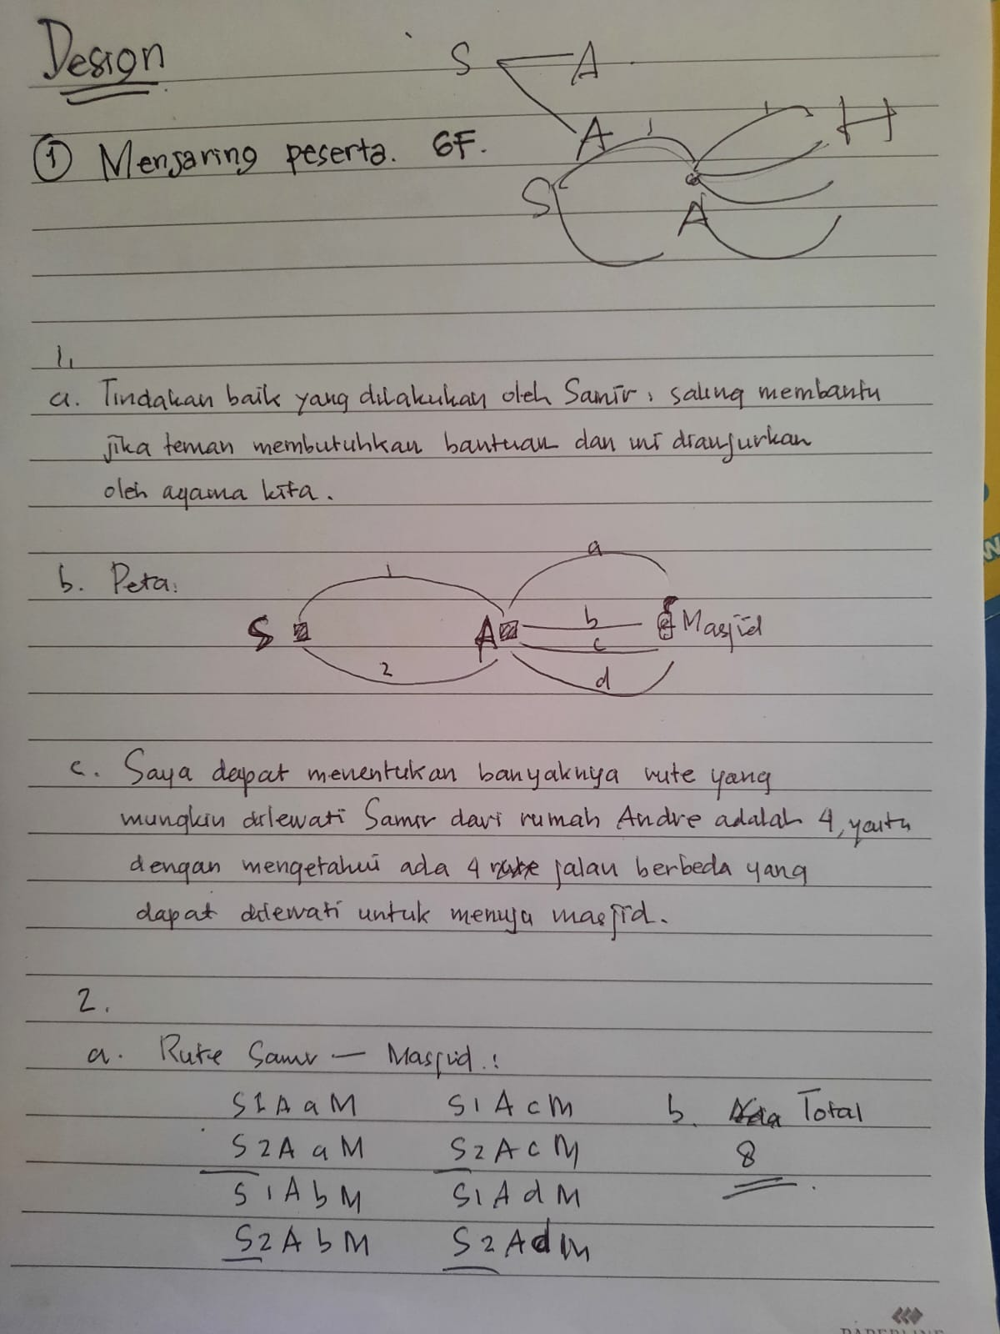
Figure 1. An example of students’ answer in determining one good Islamic value

Although the ideas of multiplication rules as well as how to use multiplication rule in determining the possible routes, had not yet been formally given to the students, the majority of them were able to rediscover the concepts using their own methods. In other words, by examining the given Islamic context (1 b) might prompt the students to consider multiplication rules. A students’ response of item 1b and 1c were apparently visible in Figure 2.

Figure 2. An example of students’ answer in rediscovering the concept of multiplication rule

In Figure 2, the student drew her own map of the possible route from Samir to Masjid An-Nur. The student made line as representation of possible routes form Samir’s house (S) to Andre’s house (A) then to Masjid An-Nur. The student symbolized and numbered the possible route in number and letters. From Samir's residence to the masjid, the student charted the only path she may take. She, then, listed the total routes from the possible routes as be visible in Figure 3.

Figure 3. An example of students’ answer in finding the total routes

After discussing the problem in the group, most students discovered how to determine the possible routes by draw their own map and interpret it to simple diagram as can be seen in Figure 2 and Figure 4. In fact, there were student who could model and interpret the problems into numbers which are possible routes that can be traveled. The number “2” in Figure 4 written at the top right symbolized the number of possible routes from Samir's house to the mosque through the first road from Andre's house, and so on (See Figure 4 at the right side). Furthermore, the student added up to 2 as many as 4 which were the possible number of routes from Andre's house to the mosque. This would be led the student to the concept of multiplication rules.

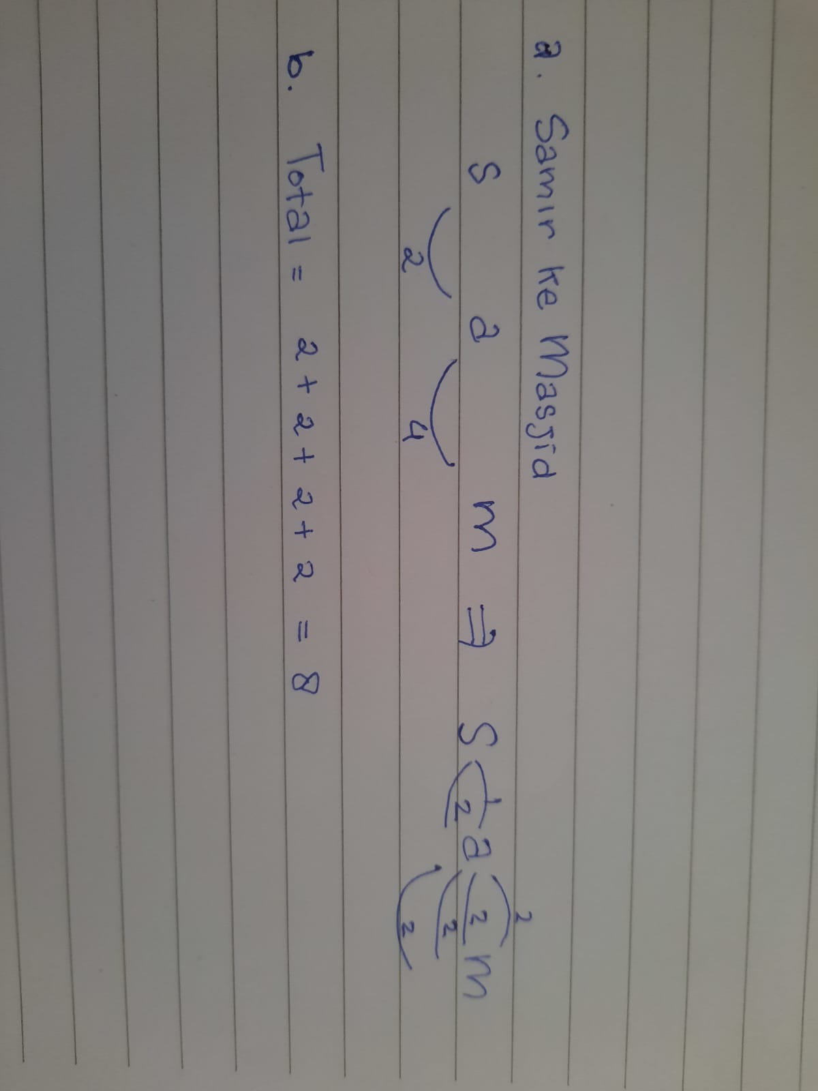
Figure 4. An example of students’ answer in determining the concept of multiplication rule

All learning activities and students’ responses above indicated that the learning trajectory (LT) developed in this study could support students in reconstructing ideas about multiplication rules. The contextual problems could facilitate in students’ reasoning and justification, developing students’ own strategies and collaboration. All of those activities are the embodiment of the key principle of RME (Fauzan et al., 2013; Gravemeijer, 1994; Heuvel-panhuizen & Drijvers, 2014; Zulkardi, 2002). In addition, the contextual problems which included Islamic values could strengthen students’ Islamic profile/value that they might have before (Muslimin et al., 2020; Putri & Aisyah, 2020).

CONCLUSION
The learning trajectory (LT) of multiplication rules based Realistic-Islamic settings could promote students understanding and reasoning about multiplication rules ideas. Four learning series: finding your way to a mosque on a map, finding your way to Friday prayer, creating your own map, and performing good actions. This approach helps students reassemble their knowledge of multiplication rules in order to predict potential outcomes. The Islamic culture may, most significantly, impart positive morals and acts that can be used in daily life.

REFERENCES
Abdussakir. (2017). Internalisasi nilai-nilai islami dalam pembelajaran matematika dengan strategi analogi. Seminar Nasional Integrasi Matematika Dan Nilai Islami, 1(1), 1–15. http://conferences.uin-malang.ac.id/index.php/SIMANIS/article/view/546
Afriansyah, E. A., & Arwadi, F. (2021). Learning Trajectory of Quadrilateral Applying Realistic Mathematics Education: Origami-Based Tasks. Mathematics Teaching Research Journal, 13(4), 42–78.
Bakker, A., & Van Eerde, D. (2013). An introduction to design- based research with an example from statistics education. In A. Bikner- Ahsbahs, C. Knipping, & N. Presmeg (2013), Doing qualitative research: methodology and methods in mathematics education. In Freudental Institute for Science and Mathematics Education (Issue September). https://doi.org/10.1007/978-94-017-9181-6
Clements, D. H., & Sarama, J. (2014). Learning trajectories. Learning over Time: Learning Trajectories in Mathematics Education, 1–30.
Cobb, P., Confrey, J., DiSessa, A., Lehrer, R., & Schauble, L. (2003). Design experiments in educational research. Educational Researcher, 32(1), 9–13.
Elizondo-Ramírez, R., & Hernández-Solís, A. (2017). Hypothetical Learning Trajectories that use Digital Technology to Tackle an Optimization problem. International Journal for Technology in Mathematics Education, 24(2).
Fauzan, A., Plomp, T., & Gravemeijer, K. (2013). The development of an RME-based geometrycourse for Indonesian primary schools. In T. Plomp, & Nieveen (Eds). Educational Design Research - Part B Illustrative Cases, 2013, 159–178.
Gravemeijer, K. P. E. (1994). Developing realistic mathematics education. Faculty of Sciences, Freudenthal Institute, 13(3), 200 pp. http://www.cdbeta.uu.nl/tdb/fulltext/199503-terwel2.pdf%0Ahttp://www.fisme.science.uu.nl/toepassingen/20014/
Gravemeijer, Koeno; Cobb, P. (2013). Design Research from the Learning Design Perspective. In T. Plomp & N. Nieveen (Eds.), Educational design research - Part A: Introduction (pp. 72–113). SLO. https://doi.org/10.1007/978-1-4614-3185-5_11
Hadi, S. (2017). Realistic Mathematics Education: Theory, Development and Implementation. Jakarta: PT Raja Grafindo Persada.
Hendriana, H., Prahmana, R. C. I., & Hidayat, W. (2019). The Innovation of Learning Trajectory on Multiplication Operations for Rural Area Students in Indonesia. Journal on Mathematics Education, 10(3), 397–408.
Heuvel-panhuizen, M. Van Den, & Drijvers, P. (2014). Realistic Mathematics Education. In S. Leman (Ed.), Encyclopedia of Mathematics Education (pp. 521–525). Springer. https://doi.org/10.1007/978-94-007-4978-8
Irawan, A., & Kencanawaty, G. (2017). Implementasi pembelajaran matematika realistik berbasis etnomatematika. Journal of Medives: Journal of Mathematics Education IKIP Veteran Semarang, 1(2), 74–81.
Isandespha, I. N. (2015). Pengembangan bahan ajar materi pembelajaran matematika sd dengan pendekatan realistik bernuansa islami untuk mahasiswa pendidikan guru sekolah dasar. Elementary School: Jurnal Pendidikan Dan Pembelajaran Ke-SD-An, 2(1).
Johnson, E. B. (2002). Contextual teaching and learning: What it is and why it’s here to stay. Corwin Press.
Kuntowijoyo, M. T. M. (2001). Esai-Esai Agama. Budaya, Dan Politik Dalam Bingkai Strukturalisme Transendental, Bandung: Mizan.
Liljekvist, I., Mellroth, E., Ollson, J., & Boesen, J. (2016). Proc. MADIF10 Development of mathematics teaching: design, scale, effects. SMDF Linköping.
Maryati, Iyam; Priatna, N. (2017). Integrasi Nilai-Nilai Karakter Matematika Melalui Pembelajaran Kontekstual. Mosharafa, 6(September), 333–344.
Muslimin, Indra Putri, R. I., Zulkardi, & Aisyah, N. (2020). Learning integers with realistic mathematics education approach based on islamic values. Journal on Mathematics Education, 11(3), 363–384. https://doi.org/10.22342/JME.11.3.11721.363-384
Nieveen, Nienke; McKenney, Susan; van den Akker, J. (2006). Educational Design Research: The Value of Variety. In N. van den Akker, Jan; Gravemeijer, Koeno; McKenney, Susan; Nieveen (Ed.), Educational Design Research (1st Editio, Issue 10 August 2006, pp. 229–240). Routledge.
Nihayati, Suningsih, A., & Abdullah, H. M. (2018). Integrasi Ayat-Ayat Bilangan Dalam Al- Qur ’ an Dengan Nilai-Nilai Islam. UIN Raden Intan Lampung, 03(02), 101–109.
Ningtyas, Y. D. W. K., Maharani, Y. Y., & Anjarsari, E. (2022). THE HYPOTHETICAL LEARNING TRAJECTORY OF ENUMERATION RULES WITH ISLAMIC VALUES. JPMI (Jurnal Pendidikan Matematika Indonesia), 7(2), 96–104.
Plomp, T. (2013). Educational design research: An introduction. Educational Design Research, 11–50.
Prahmana, R. C. I. (2017). Design Research:(Teori dan Implementasinya: Suatu Pengantar).
Putri, R. I. I., & Aisyah, N. (2020). Learning Integers with Realistic Mathematics Education Approach Based on Islamic Values. Journal on Mathematics Education, 11(3), 363–384.
Rahman, B., Abdurrahman, A., Kadaryanto, B., & Rusminto, N. E. (2015). Teacher-based scaffolding as a teacher professional development program in Indonesia. Australian Journal of Teacher Education, 40(11), 66–78. https://doi.org/10.14221/ajte.2015v40n11.4
Risdiyanti, I., Prahmana, R. C. I., & Shahrill, M. (2019). The learning trajectory of social arithmetic using an indonesian traditional game. Elementary Education Online, 18(4), 2094–2108. https://doi.org/10.17051/ilkonline.2019.639439
Salafudin, S. (2015). Pembelajaran Matematika Yang Bermuatan Nilai Islam. Jurnal Penelitian, 12(2), 223. https://doi.org/10.28918/jupe.v12i2.651
Sembiring, R. K., Hadi, S., & Dolk, M. (2008). Reforming mathematics learning in Indonesian classrooms through RME. ZDM, 40, 927–939.
Treffers, A. (2012). Three dimensions: A model of goal and theory description in mathematics instruction—The Wiskobas Project (Vol. 3). Springer Science & Business Media.
Van den Heuvel-Panhuizen, M., & Drijvers, P. (2020). Realistic mathematics education. Encyclopedia of Mathematics Education, 713–717.
van Galen, F., Feijs, E., Figueiredo, N., Gravemeijer, K., van Herpen, E., & Keijzer, R. (2008). Core insights into percentages. In Fractions, Percentages, Decimals and Proportions (pp. 89–105). Brill.
Zulkardi. (2002). Developing A Learning Environment On Realistic Mathematics Education For Indonesian Student Teacher (Doctoral disertation) [University of Twente]. https://repository.unsri.ac.id/6353/1/thesis_Zulkardi.pdf
Zulkardi, Z., Putri, R. I. I., & Wijaya, A. (2020). Two decades of realistic mathematics education in Indonesia. International Reflections on the Netherlands Didactics of Mathematics: Visions on and Experiences with Realistic Mathematics Education, 325–340.

