STUDENT’S PERCEPTIONS OF THE USE OF GOOGLE MEET DURING THE LIMITED FACE-TO-FACE LEARNING PERIOD

M. Labib Al Halim
E-mail: labibhalim27@gmail.com
English Education Study Program, University of Billfath

ABSTRACT

This research aims to describe student’s perceptions of the use Google Meet during the limited face-to-face learning period at English Education Study Program University of Billfath. This research employed descriptive quantitative research techniques in the form of surveys. An online questionnaire created with Google Forms was used as the research instrument. The result of student’s answer through the questionnaire given showed good category. There were 60% of students strongly agree with the statement that Google was easily accessible, 52% of students strongly agree with the use of Google Meet, they could still understand the material given during lectures, 44% of students strongly agree that the use of google meet during online learning was effective, and 40% of students were highly motivated to participate in learning by using google meet. Thus, it could be concluded that online learning using Google Meet during the limited face-to-face learning period was quite good and effective.

Keywords: Google Meet, Limited Face-to-Face Learning, Student’s Perception.

Introduction
Since the entry of Covid-19 in Indonesia in early 2020, the Covid-19 virus outbreak has had a significant global impact, as well as in Indonesia. All human activities ranging from the economic, tourism, social, industrial and educational sectors are affected. In education, especially learning activities in schools, it is temporarily suspended but students must continue to study (Syaharuddin, 2020). In its spread, COVID-19 needs to be prevented as good as possible. In accordance with the government's recommendation through the Ministry of Education and Culture, implementing the policy of learning and working from home starting in mid-March 2020. Likewise with learning activities in education, all levels of education from elementary school to college, face-to-face learning in schools is temporarily suspended for an undetermined time.
In the educational environment, a new policy is applied, it’s the policy of learning from home or virtually. The government recommends teachers and students to stay at home and have social distancing. The educational process should be carried out through online via internet. The educational process conducted through online needs to pay attention and consider various factors such as the techniques used by teachers. The selection of learning techniques must be in accordance with the school's abilities and competencies possessed by teachers and students (Sutarto et al., 2020).
Learning through online has advantages and disadvantages. Online learning activities can make learning not monotonous, time efficiency and the materials that are very easy to access (Yuhanna et al., 2020). In the process, online learning using information technology can support and facilitate the delivery of materials and assignments. Some of the learning media that are widely used in online learning are zoom meeting, google classroom, google meet, and WhatsApp (Fuady et al., 2021). From these applications, several applications provide video conferencing facilities that can be used by more than 100 people, such as zoom meetings and google meet. Google meet is part of the Google Hangout feature that provides video conferencing facilities that can be used by more than 100 people live. Google Meet is Google's paid service. It has a significant impact on student’s learning enthusiasm because it is simple to use, flexible time, and can be held wherever students are (Purwanto & Tannady, 2020).
Google Meet is one of the most widely used communication platforms today. Google Meet is a replacement for the Google Hangouts and Google Chat apps. Google Meet was just released in February 2017. Google Meet is a type of audio-visual learning media because it can produce sound and images. In addition, Google Meet is also included in the type of computer technology learning media.
The use of Google Meet is expected to make it easier for teachers and students to interact. Google Meet can be used as a medium to manage learning and convey information quickly and accurately to students through Video Conference services. Here are some of the features available on Google Meet: 1) Provides multi-way audio-video calls with 720p resolution, 2) Encryption of all calls is available, 3) Has noise cancelling filter, 4) Has a low light mode, 5) Can be used via web browser, android or IOS, 6) Can connect directly from Google Calendar and Google Contacts, and 7) Provide a share screen service that can be used to present documents, spreadsheets, images, and others.
As a Learning Media The selection of Google Meet as an online learning medium has many advantages when compared to other media, such as: 1) Mobile Friendly so it is very easy to use for users who are first time using Google Meet, 2) Make it easier for students with students, students with teachers, teachers with parents in communicating during the covid-19 pandemic, 3) Make it easier for teachers to deliver material directly to students because Google Meet is equipped with a Share Screen feature that can be used to share material in the form of documents, 4) Provide a white board feature that can be used to clarify and make it easier for teachers to explain teaching materials, 5) Can be used efficiently and flexibly, 6) Students can directly convey thoughts, ideas, and questions related to the material presented, 7) Accessible for free, and 8) Online learning is not monotonous.
During the COVID-19 pandemic, students' self-regulated learning at home with the help of information technology must be done to avoid social distancing. Electronic-based education and learning (e-learning) with internet facilities really runs completely because it is driven by the pandemic situation (Wang et al., 2013). Distance and physical contact that has the potential to spread the virus must be regulated. The implementation of learning which was originally carried out face-to-face in the classroom, must be changed to online learning. The ministry believes that the implementation of online learning can prevent crowds of students in the classroom and in the campus area (Aguilera-Hermida, 2020). Students and teachers can carry out lectures from their respective places so that there is no physical contact between teachers and students and prevents physical contact with other people. The application of online learning can reduce the emergence of mass crowds on campus as happens in face-to-face lectures. The educational process that that passed during the covid- 19 epidemic required lecturers and students to use technology as a means for online learning. The teacher can choose the right application as a means of online learning.
Therefore, this research focused on identifying the use of Google Meet in online courses for English majors at the University of Billfath Lamongan during the limited face-to-face learning period. Using Google Meet is easier and simpler because the users don't need to download it. The students can just open Google Chrome and log in with an available email address to access it. Google meet is able to be accessed through the website, Android and iOS. Google meet has a fairly good quality of service and can also accommodate more than 100 people in each teleconference. Lectures using Google meet, teachers can view student learning documents and can make presentations, display materials, and record them. In the learning process, students can turn on videos so that lecturers can control student attendance and activities so that the learning atmosphere looks like in class (Purwanto & Tannady, 2020).

RESEARCH METHOD
This research used descriptive quantitative research by (Sugiyono, 2011) using survey techniques. An online questionnaire administered via Google Form was used as the research instrument.
Population
The population of this research were all students of English majors at University of Billfath in the odd semester for the 2021/20222 academic year. The research sample was carried out using a non-probability sampling method with a purposive sampling approach (Arikunto, 2010). The sample is all students of English Education Study Program who have filled out a questionnaire as many as 48 people.

Data Sources and analysis
This research used primary data derived from respondent’s answers by using a questionnaire containing a number of questions that have been given weights. The questionnaire was given to students of English Education Study Program who were researching through online learning in the odd semester 2021/2022. The questionnaire given consists of four indicators with the answer using four Likert Scale categories, namely Strongly Disagree, Disagree, Agree, and Strongly Agree. This research was conducted along five months from September to January 2022 using Mc. Excel for data processing.

No | Indicators
1 | Students’ response in accessing the Google Meet Application
2 | Students’ understanding of the material given through Google Meet Application
3 | The effectiveness of using Google Meet Application in learning
4 | Students’ learning motivation by using google meet during online learning
Table 1. The indicators of the questionnaire

The data was obtained from the questionnaires, and interview. Each answer from the questionnaires has different a score. The questions given was using a Likert scale measuring instrument with a maximum value of four as shown in Table 2. In answering the questionnaires given, students are asked to provide the response based on what they feel.
Answer Type | Score
Strongly Disagree | 1
Disagree | 2
Agree | 3
Strongly agree | 4
Table 2. Likert Scale and Score

Data Presentation
In presenting the data, two methods were used, namely in the form of diagrams and description. The diagram made it easy for readers to see the results quickly and systematically. The form of presentation was also more efficient and effective in drawing further conclusions. While the description explained more detail from the diagram image presented.

FINDINGS AND DISCUSSION
Findings

Student’s perceptions of the use of google meet during the limited face-to-face learning period could be seen below:
- Students’ response in accessing the Google Meet Application
The results of an online scale survey for students majoring in English in the odd semester of the 2020/2021 academic year regarding the ease of accessing the Google Meet application, it showed that 60% of students answered strongly agree, 38% agree, 2% disagree, and 0% strongly disagree. A total of two students gave answers that they disagreed with the ease of use of Google Meet. It was constrained by the internet network in their area. Overall, it could be interpreted that most students strongly agree with the statement that Google was easily accessible.

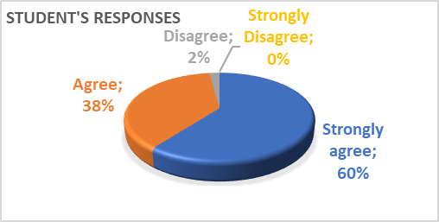
Diagram 1. Students’ response in accessing the Google Meet Application

- Students’ understanding of the material given through Google Meet Application
The second indicator in this research was a statement of the student's ability to understand the material delivered through the Google Meet application. Based on students' opinions, it showed that as many as 52% of students strongly agree with the use of Google Meet, they could still understand the material given during lectures. As many as 40% answered that they were agreed that they could still understand the material given through Google Meet, and the remaining 8% answered that they are disagree. Based on student’s opinion, the use of Google Meet was very efficient because they could directly communicate with the teacher, thus the material explained by the teacher could be understood well. In addition, students could also discuss directly with the teacher if there was material that has not been understood.

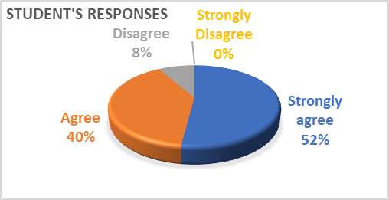
Diagram 2. Students’ understanding of the material given through Google Meet Application

- The effectiveness of using Google Meet Application in learning
Based on student’s answered about the effectiveness of using Google Meet Application in learning, it showed that 44% of students said strongly agree, 48% agreed, 8% disagree, and 0% strongly disagreed. The existence of material exposure from the teacher during learning with Google Meet either through presentation slides, videos or others as well as interactions between students and teachers has given the impression as in conventional learning. The only difference was that the learning process was done from home. In addition, the teacher could supervise student’s activities while learning was being carried out. It’s because Google Meet was facilitated with screen recording features and cameras that could be used by the users.
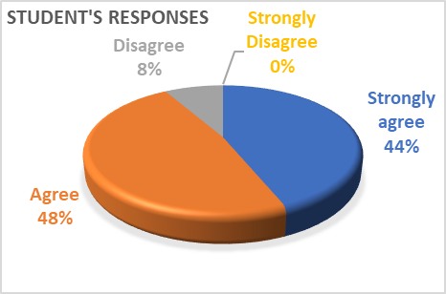
Diagram 3. The effectiveness of using Google Meet Application in learning

- Students’ learning motivation by using google meet during online learning

The student’s answer showed that most students are still motivated in online learning through google meet. It could be seen from the results of the percentage of the questionnaire which stated that 40% of students were highly motivated to participate in learning by using google meet, 46% stated that they were motivated, 12% stated that they were not motivated, and the remaining 2% of students stated that they were less motivated to learn by using google meet. This was supported by the desire of students to take advantage of technology from an early age, so it could provide a meaningful experience for these students.

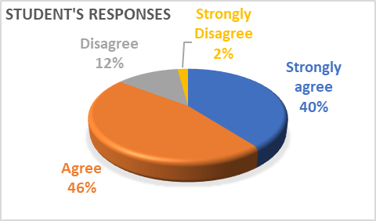

Diagram 4. Students’ learning motivation by using google meet during online learning
Discussion
The results of all aspects listed in the student’s response questionnaire to online learning showed a good category. It meant that students have a good response to online learning during the limited face-to-face learning period, even though the results of interviews showed that there were still some obstacles in online learning, such as signals, quota prices which were quite difficult for students but it was not serious obstacles in learning. It’s because all the problems could be resolved properly so online learning can still be carried out well.
The effectiveness of using Google Meet in online learning could also be seen during the implementation. The use of Google Meet was very effective in online learning today. Teachers could take advantage of various features available in Google Meet such as share screens to share material on the screen, chat fields for students to take attendance or convey ideas, thoughts, and questions related to material that has not been understood.
In addition, Google Meet was also equipped with audio-visual, so it could make it easier for teachers and students to interact during the current limited face-to-face learning. Teachers could evaluate directly by observing students during learning. Teachers could also evaluate students' spiritual attitudes and students' social attitudes during the online learning process.

CONCLUSION AND SUGGESTION
Conclusion
Based on the result and discussion above, it showed that online learning using Google Meet during the limited face-to-face learning period was quite good and effective. It’s because there were many features served by Google Meet such as share screens to share material on the screen, chat fields for students to take attendance or convey ideas, thoughts, and questions regarding material that has not been understood. In addition, the use of Google Meet was also equipped with audio-visual, so the teachers could evaluate directly by observing students during learning. The results of this research are expected to be a reference by educators in choosing learning media during online learning, thus the learning and teaching process can run smoothly, and the material can be conveyed properly to students.
Suggestion
for further researchers, the results of this study could be used as comparison and reference for research, and as consideration for further deepening research by comparing several learning platforms during this limited face-to-face learning period.
REFERENCES
Aguilera-Hermida, A. P. (2020). College students’ use and acceptance of emergency online learning due to COVID-19. International Journal of Educational Research Open, 1, 100011.

Arikunto, S. (2010). Metode peneltian. Jakarta: Rineka Cipta.

Fuady, I., Sutarjo, M. A. S., & Ernawati, E. (2021). Analysis of students’ perceptions of online learning media during the Covid-19 pandemic (Study of e-learning media: Zoom, Google Meet, Google Classroom, and LMS). Randwick International of Social Science Journal, 2(1), 51–56.

Purwanto, E., & Tannady, H. (2020). The factors affecting intention to use google meet amid online meeting platforms competition in Indonesia. Technology Reports of Kansai University, 62(06), 2829–2838.

Sugiyono, P. (2011). Metodologi penelitian kuantitatif kualitatif dan R&D. Alpabeta, Bandung.

Sutarto, S., Sari, D. P., & Fathurrochman, I. (2020). Teacher strategies in online learning to increase students’ interest in learning during COVID-19 pandemic. Jurnal Konseling Dan Pendidikan, 8(3), 129–137.

Syaharuddin, S. (2020). Menimbang Peran Teknologi dan Guru dalam Pembelajaran di Era COVID-19. Menimbang Peran Teknologi Dan Guru Dalam Pembelajaran Di Era COVID-19.

Wang, C.-H., Shannon, D. M., & Ross, M. E. (2013). Students’ characteristics, self-regulated learning, technology self-efficacy, and course outcomes in online learning. Distance Education, 34(3), 302–323.

Yuhanna, I., Alexander, A., & Kachik, A. (2020). Advantages and disadvantages of Online Learning. Journal Educational Verkenning, 1(2), 13–19.

